Internship 2022

# Progress report format for team meeting

Name: Cynthia Kemboi

## Tasks completed last week

* [#7] Identification of parts used in making the robot car- The parts were identified, listed down and explained what each part will be used for together with their specifications.
* [#8] A drawing of the chassis for the robot car- With the aid of the AutoCAD software, the upper and lower chassis was drawn. The attachment parts were also drawn using AutoCAD.

Wheels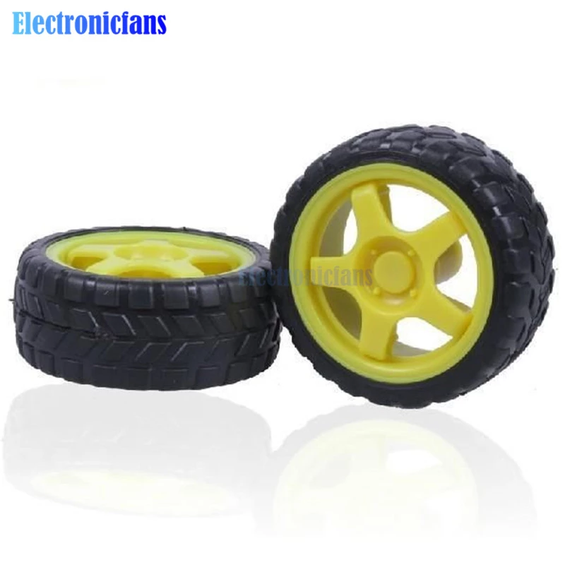Buzzer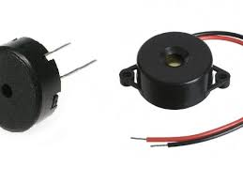RF module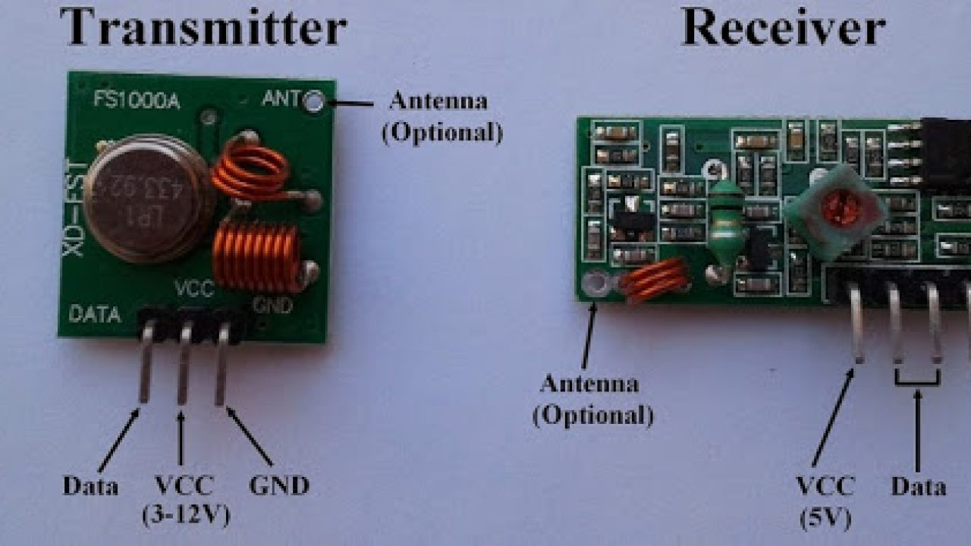Motor shield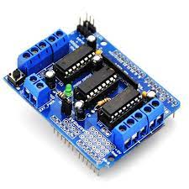Gyroscope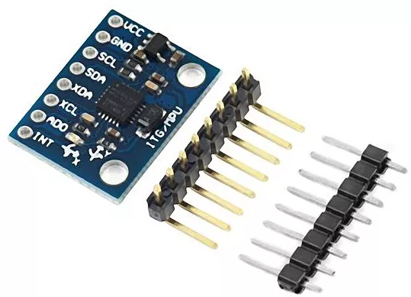Gps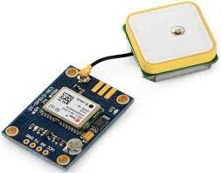Servomotor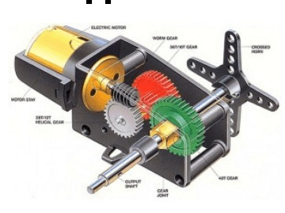Ultrasonic sensor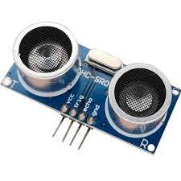DC Motor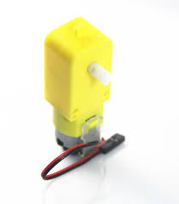Arduino mega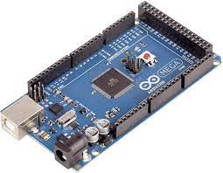

## Tasks in this week

* [#9]Circuit diagram of the robot car- Draw the circuit diagram for the robot car using Fritzing.
* 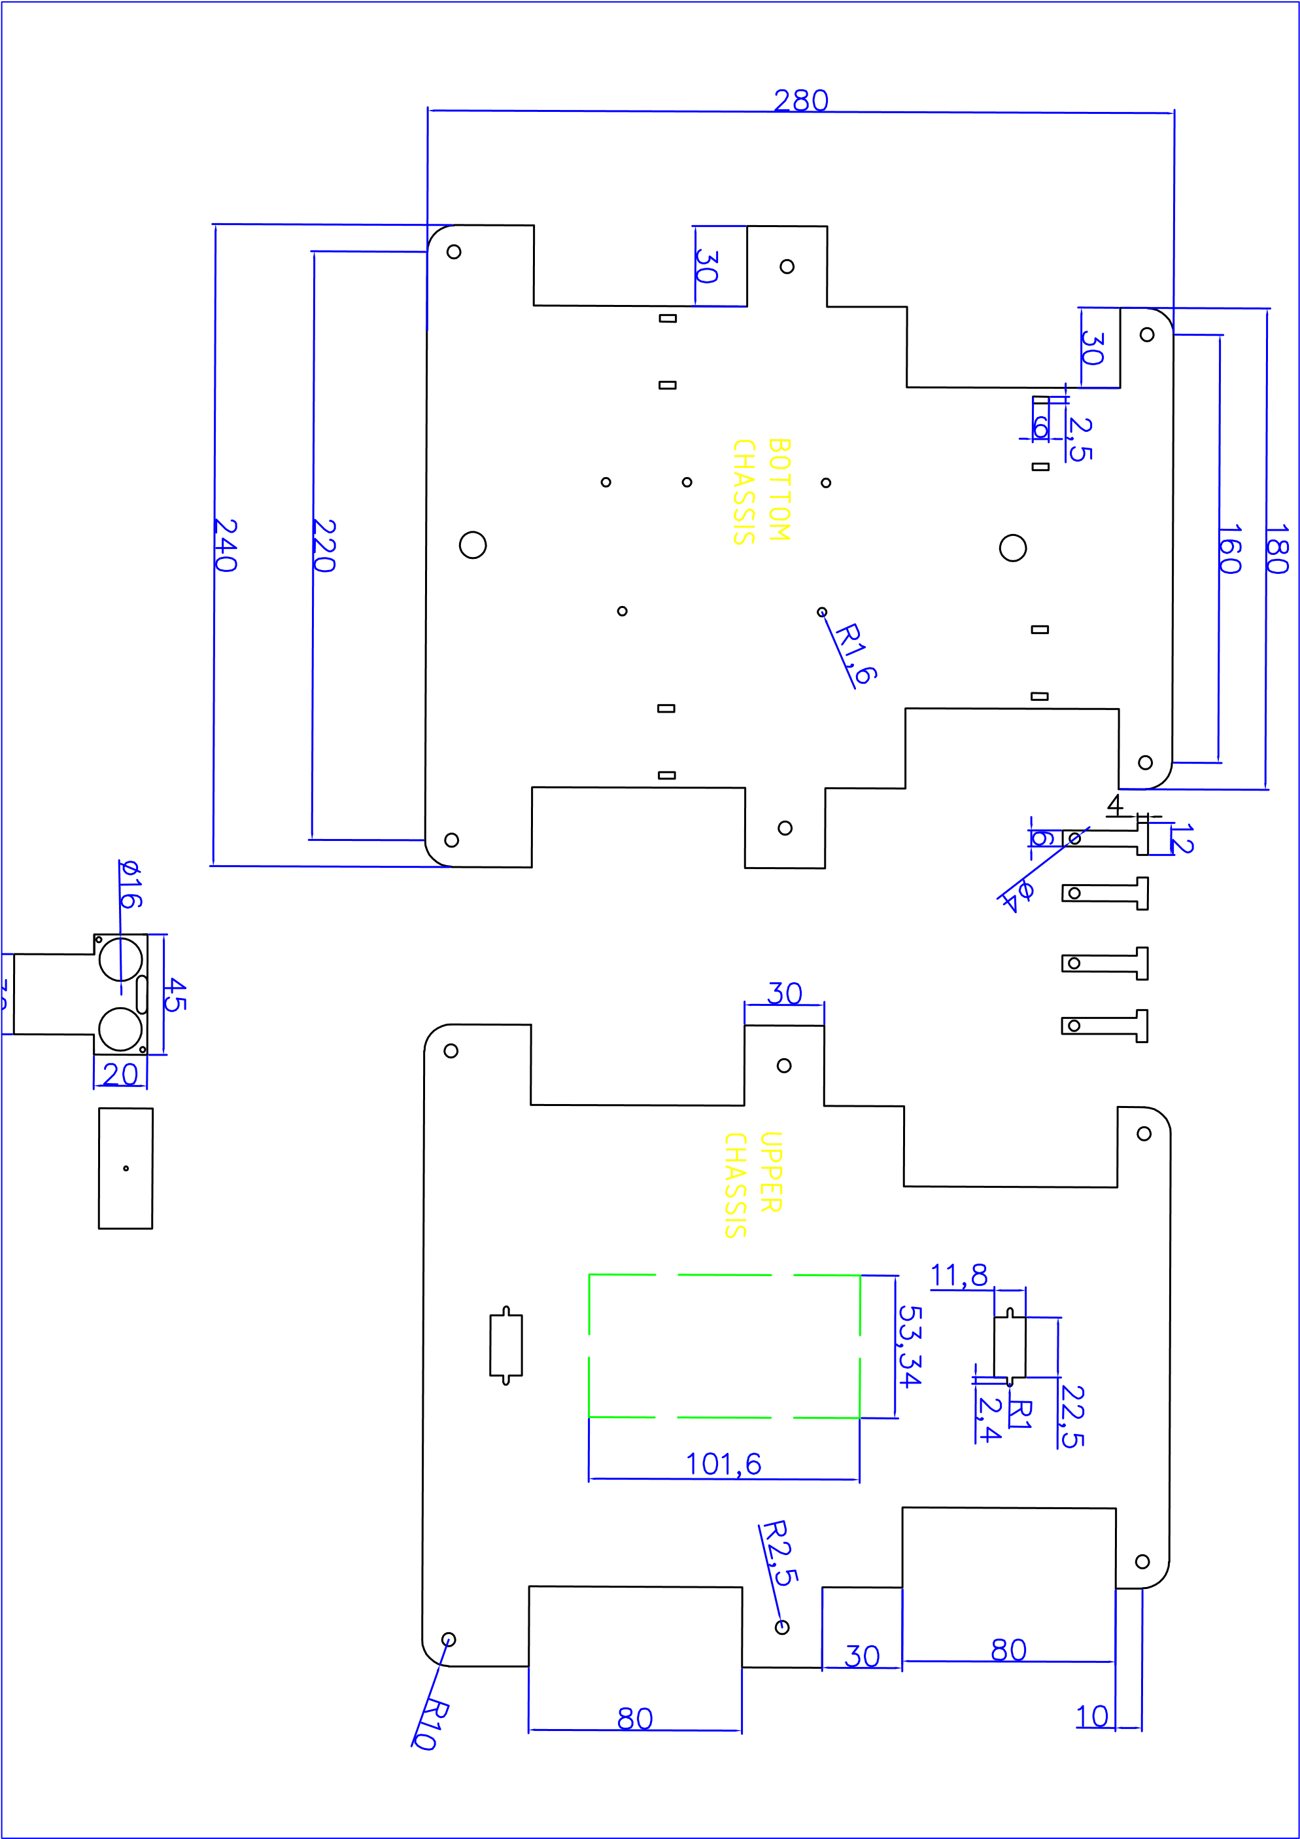

## Timeline

|  |  |  |
| --- | --- | --- |
| Month | Intern week | Tasks |
| Jan |  |  |
| Week 1 | Identification of parts and drawing of the chassis diagram |
| Week 2 | Circuit diagram and acquisition of parts. |
| Week 3 |  |
| Feb | Week 4 |  |
| Week 5 |  |
| Week 6 |  |
| Week 7 |  |